Hello guys, please help.

I'm falling behind because I've been struggling with these flex boxes, I don't know what am I doing wrong or not even doing. I've been dancing with this for over 6-hours each day since last week

<https://dyantyim.github.io/wdd130/wwr/about.html>

About Us

[Screenshot 2024-10-03 155912.png](https://webmailbyui.sharepoint.com/sites/Course_wdd_130-P0xufOHOZJCIb/Shared%20Documents/General/Screenshot%202024-10-03%20155912.png)

[Screenshot 2024-10-15 235628.png](https://webmailbyui.sharepoint.com/sites/Course_wdd_130-P0xufOHOZJCIb/Shared%20Documents/General/Screenshot%202024-10-15%20235628.png)

[Screenshot 2024-10-15 235832.png](https://webmailbyui.sharepoint.com/sites/Course_wdd_130-P0xufOHOZJCIb/Shared%20Documents/General/Screenshot%202024-10-15%20235832.png)

You must change this property from a background-image to be an image in the HTML

    background-image: url(https://byui-cse.github.io/wdd130-ww-course/resources/images/hero_transparency_1024.png);

WE do not use that background-image property in this class. All images must be links in HTML.

You must be using the postiion: relative in the .hero rule with the position:absolute in the .hero h1 and article rules to place the items where you want them.

this rule must have a max width

article img {  
    float: right;  
}

and you must rename it to be this or the .hero img rule will still apply.

.hero article img

This is not allowed in the HTML file. All CSS must be in the CSS file.

<style>  
            .hero{  
            width: auto;  
            height: 400px;  
            padding: 20px;  
            margin: auto;  
            box-shadow: 0px 0px 10px 2px grey;  
            font-family: Verdana, Geneva, Tahoma, sans-serif;  
            background-image: url(https://byui-cse.github.io/wdd130-ww-course/resources/images/hero_transparency_1024.png);  
            background-size: auto;  
            text-align: center;  
            }  
</style>

This is incorrect

<header>  
<nav>  
<img src="images/Logo.jpg" alt="">  
<a href="#">home</a>  
<a href="wwr">about us</a>  
<a href="wwr">Trips</a>  
<a href="wwr">Contact us</a>  
</nav>  
</header>

You must put the filenames in the href part and the img goes before the nav tag.

You MUST put test describing the img in the ALT property. This is madatory for all images.

<header>

          <img src="images/Logo.jpg" alt="log">  
<nav>  
  
<a href="index.html">home</a>  
<a href="about.html">about us</a>  
<a href="trips.html">Trips</a>  
<a href="contact.html">Contact us</a>  
</nav>  
</header>

These filenames were given to you in week 3 instructions. The details will make or break how yoru page looks.

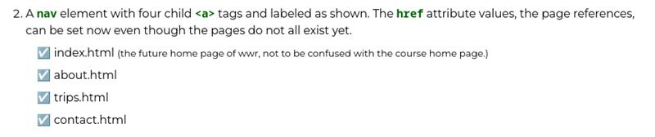

Also this thread must be moved to the STuend Help channel. The General channel is not for studnet help questions. You also posted Python code for your images.